**Research on the projectiles based around a fantasy theme:**

Residing in the realm of fantasy, projectiles can be in a varying array of shapes and sizes and appearance. Many different types of projectile can be made from this, for example you have:

Melee based Projectiles: These are the bread and butter of fantasy and fantastical weaponry, they are projectiles based on more traditional weapons of siege and melee combat. These kind of weapons usually have ties and roots to the medieval era. Amongst the many different weapons that come out of medieval and medieval fantasy, one reappearing trait that they all share in order to be a projectile is the length. As obvious as it sounds effective melee projectiles all have a length that allows the wielder to throw said weapon, and therefore have it travel at an effective speed and reach an effective range.

The most common examples of these weapons are items such as staves and polearms such as Halberds and Glaives. These polearm weapons are used a lot within the realm of fantasy and has had many appearances in fantasy, all with different shapes of their blade, spikes, tip and pole.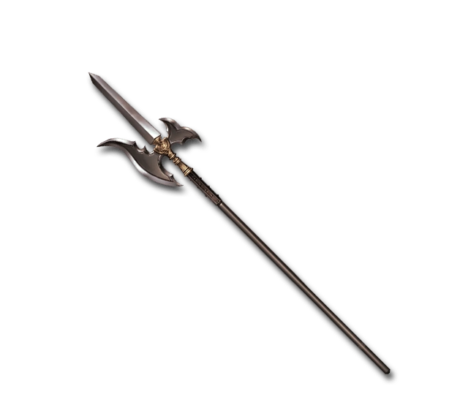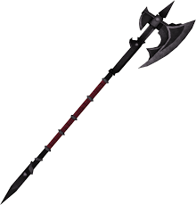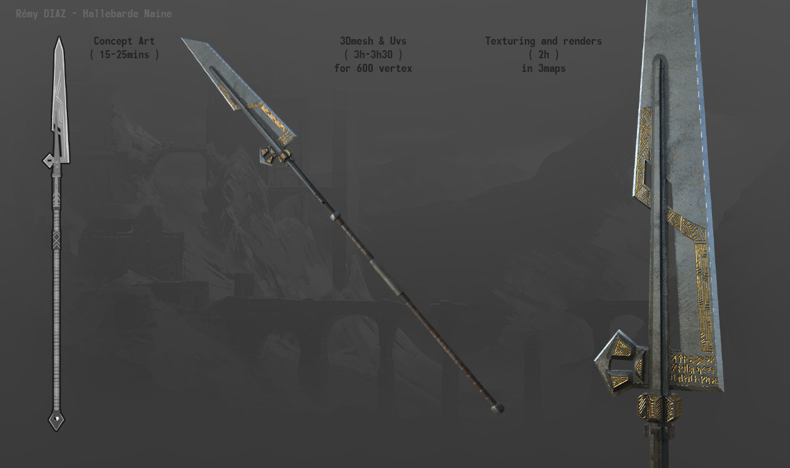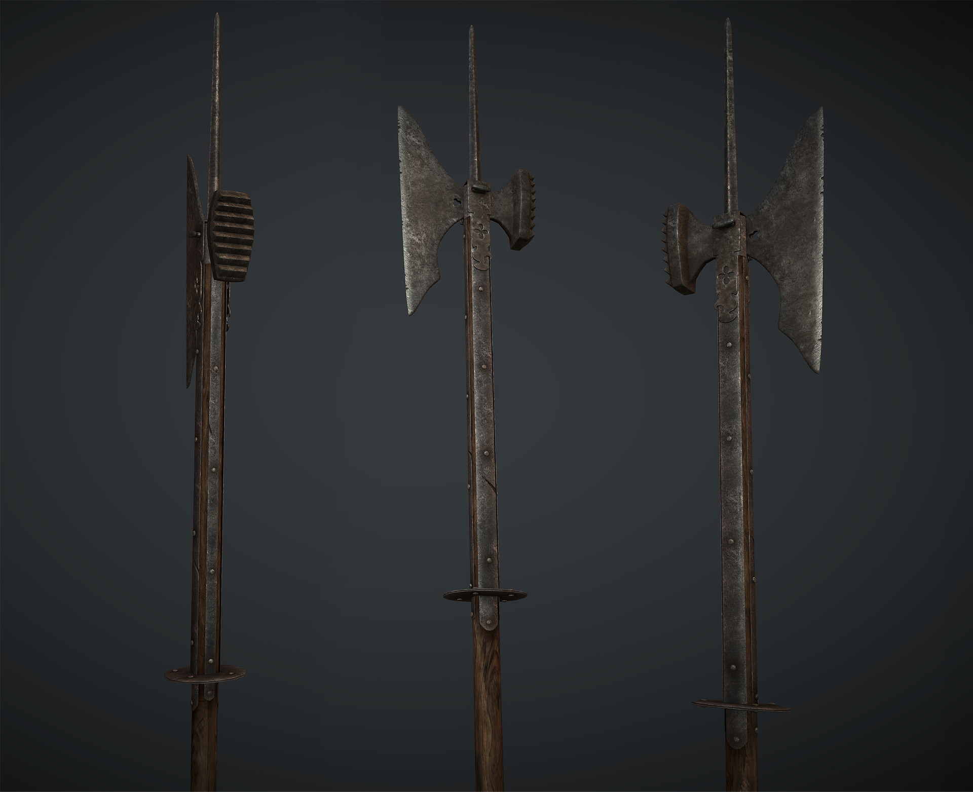

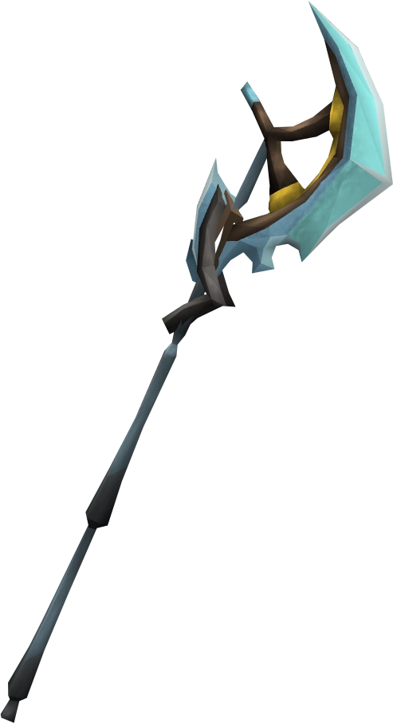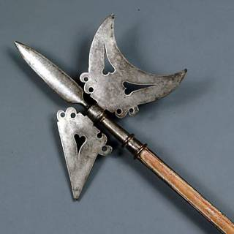

Another type of projectile weaponry used commonly in fantasy is the type of weapons that can be shot instead of thrown. These weapons are typically used to shoot some form of projectile, for example the traditional bow uses arrows to shoot from the bow. Inside the realm of fantasy these kind of weapons are kept quite simple in regards to how they work, but where they differ is the kind of object or projectile that they fire. Some of the more unique fantasy weapons of this kind of use more utility based projectiles like grappling hooks and nets or traps.

As far as the device that shoots the projectiles go there is no massive change in appearance as most of the devices used in fantasy have strong roots to medieval era and it’s siege weaponry. For example there is the traditional bow as mentioned above and others such as the trebuchet, ballista, catapult and the less conventional crossbow. These are all weapons that share a similarity in their appearance, in that they act as a catalyst for the projectile they can hold and in some way shoot.

